Product Complaints
Q-0029

Revision History
Rev | Date | Status | Originator | ECO | Description
A

Training Required
Responsibility Type | New Personnel | Trained on Previous Revision
All MedCommons Personnel | Core Quality System Training  or  Postmarket Process Training for those who have already received Core Quality System Training | Not applicable for Rev A
Complaint Coordinators | Instructor-led | Not applicable for Rev A

Purpose
The Product Complaint procedure identifies situations that meet FDA’s definition of complaints. Complaints are evaluated, investigated and corrected as appropriate. Complaints may be upgraded to safety complaints. Complaints may result in corrective or preventive actions. Complaint records are maintained in the MedCommons Complaint File.

Scope
This document applies to procedures for:
- identifying MedCommons complaints
- evaluating and investigating complaints
- creating and retaining records of complaints
- reporting complaint metrics to responsible managers

Responsibilities

MedCommons Personnel
MedCommons personnel document and deliver suspected complaints to the Complaint Coordinator in the Quality/Regulatory Department. When MedCommons personnel identify potential safety complaints, they notify the Complaint Coordinator immediately.
Designated personnel:
- review communications from customers for potential complaints
- review service records for potential complaints
- assist with complaint evaluations, investigations, and corrective actions as requested

Complaint Coordinator
The Complaint Coordinator:
- reviews and maintains complaint documentation
- coordinates and facilitates complaint evaluation and investigation

Referenced Documents
Q-0030 Safety Complaints and Mandatory Reporting
Q-0016 Product CAPA
Q-0029 Form A Product Complaint Record

Definitions
Complaint: Any written, electronic, or oral communication relative to the identity, quality, durability, reliability, safety, effectiveness or performance of MedCommons products.
Malfunction: Any failure of the equipment to perform as intended or as specified in labeling.

Process
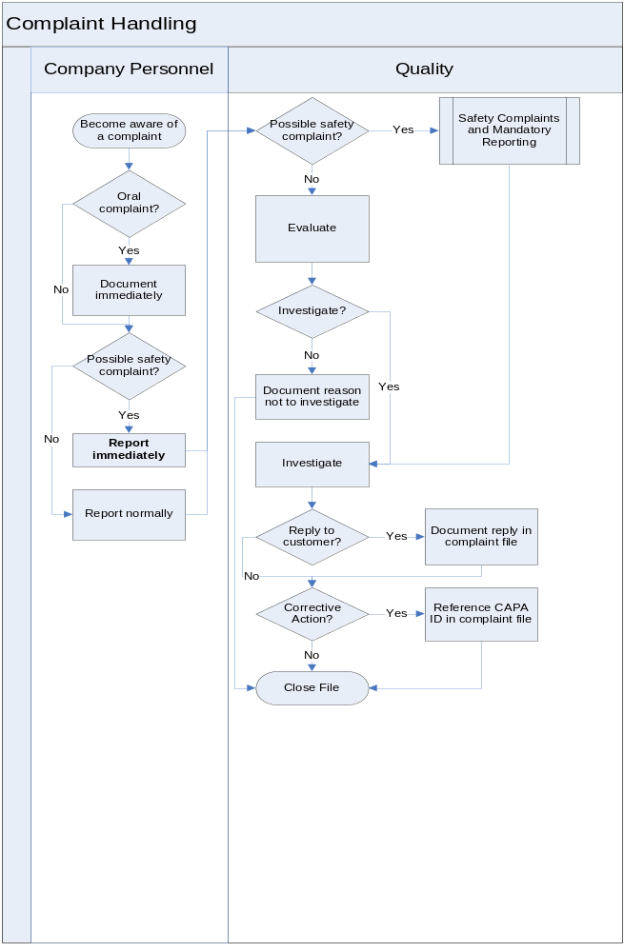
Become aware of a complaint | MedCommons personnel learn of complaints from many sources including:  - Customer communications to MedCommons personnel  - Published articles discussing MedCommons products  - Service requests  - Returned goods  - MedCommons testing which discovers problems which may exist in shipped product
Oral complaint? Document immediately | When MedCommons personnel receive an oral complaint, they document the complaint information immediately. Documentation includes:  - the nature of the complaint  - product involved  - location  - date and time of the complaint  - complainant and contact information  - other contact for follow-up (if not the complainant)
Possible safety complaint? Report immediately | A potential complaint may be a safety complaint if the incident involves a death, injury, or adverse health event or involves a malfunction that, if it recurs, is likely to cause or contribute to a death, injury, or adverse health event.  MedCommons personnel notify the Complaint Coordinator by phone or email immediately after learning of a potential safety complaint.
Report normally | MedCommons personnel notify the Complaint Coordinator by email. If additional information is not of a form that can be attached to an email, it is carried or mailed in hard-copy.
Possible safety complaint? Safety Complaints and Mandatory Reporting | If the Complaint Coordinator believes the complaint may be a safety complaint, it is processed per Safety Complaint and Mandatory Reporting in addition to the requirements of this procedure.  A possible safety complaint must be investigated. In addition to the investigation requirements listed below, records of the investigation of a safety complaint must contain:  - whether the device failed to meet specifications  - whether the device was being used for treatment or diagnosis  - the relationship, if any, of the device to the reported incident or adverse event
Evaluate | Each complaint is identified by a complaint number of the form Q-0029 Form A nnn, where nnn is a number issued sequentially, e.g., 001, 002, …  Each complaint is evaluated to determine if an investigation is needed. If an investigation is not performed, the reason is documented with the name of the individual making the decision.  Any complaint involving the possible failure of a device, labeling, or packaging to meet any of its specifications is investigated unless such an investigation has been made and documented for another complaint and additional investigation is not needed.
Investigate  Reply to customer? Document reply in the complaint file  Corrective Action? Reference CAPA ID in complaint file | For any complaint that is investigated, the complaint file shall include:  - the name of the device  - the date the complaint was received  - any device identification(s) or control number(s) used  - the name, address, and phone number of the complainant  - the nature and details of the complaint  - the dates and results of the investigation and investigators names  - any correction or corrective action taken (including reference to the CAPA identifier, if any)  - any reply to the complainant
Close File | The Complaint File is closed after:  - evaluation concludes that investigation is not needed, or  - investigation and correction or corrective action, if any, are completed.

